Graffham Down An Evolving Success Story That Needs Your Help

Graffham Down is found along the South Downs Way between Duncton and Cocking. The Down has a combination of chalk grassland, woodland and scrub. In the 1980s, when the Common Agricultural Policy was encouraging self sufficiency at almost any cost to the environment, a visionary group of individuals in Graffham Village formed the Graffham Down Trust to preserve as much nature as they could for indigenous fauna and flora. Over the decades the Trust has managed to expand it’s area under management to over 70 acres or more than 30 hectares. Roughly split 50:50 between chalk grassland and woodland/scrub.
Graffham Down Trust has been working closely with Natural England, Butterfly Conservation, South Downs National Park Authority, Arun and Rother Connections, Sussex Dormice and many others in managing and monitoring the reserves.
In addition to the established populations of Purple Emperor, Marbled White, Meadow Browns, Brimstones, Skippers, Hedge Brown, Peacock, Red Admiral, Speckled Wood, Ringlet, Dingy Skipper and many many more; 2016 saw the return of the Duke of Burgundy to Graffham Down and the identification of Cosnard’s Netwinged Beetle (one of the rarest insects in Britain) on the reserves.
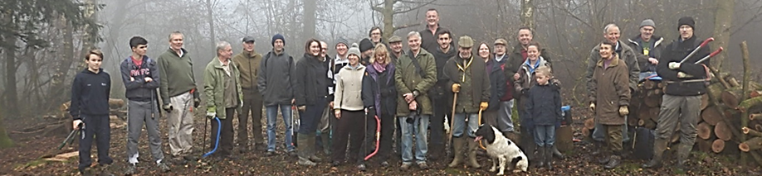
The reserves are managed 100% by volunteers with the help of some rare breed Badger Faced Sheep. The current focus of management is to maintain a diverse range of habitats from chalk grassland to woodland with plenty of glades, rides and opportunities for different species of fauna and flora. A key role of the reserves is to provide connectivity for the various species between the more prevalent areas of grassland to the East and West.
This all requires a lot of physical work by volunteers. In the 2016/17 season, Graffham Down Trust are embarking on monthly ‘mega’ work parties including the offer of lifts from Graffham Church up to the Down and cake (hopefully with tea/coffee). The dates are planned to be:
Sat 15th October
Sun 20th November
Sat 10th December
Sun 29th January
Sat 25th February
Sat 18th March
Saturday 1st April
Any help will be very much appreciated and if you are willing or able to come along please can you contact Jim Kirke on jimkirke@hotmail.com. For more information please have a look at the Trust’s website. http://www.graffhamdowntrust.org.uk/

